Intel® AI Academy

 Share

[Apply](https://software.intel.com/en-us/ai-academy/ambassadors/apply)

Intel® Student Ambassador Program

for Artificial Intelligence

As part of the Intel® AI Academy, get access to newly optimized frameworks and technologies, hands-on training, and technical resources for graduate and PhD students from top universities worldwide to further innovation in AI.

Benefits



**Free software, tools, and libraries**

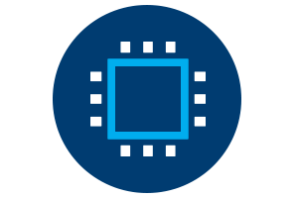

**Direct access to the Intel® AI DevCloud**



**Get early access to information and hardware**

[Join](https://software.intel.com/en-us/ai-academy/ambassadors/apply)

[Details](https://software.intel.com/en-us/ai-academy/ambassadors/details)